**Name:: Ayush Prajapati Day-1**

**College:: Aditya Silver Oak Institute of Technology**

**Branch:: Information Technology(BE)**

**Semester:: 7th**

**Task – 1**

**Linux Commands with Examples::**

1. **pwd Command**

* **The [pwd](https://www.javatpoint.com/linux-pwd) command is used to display the location of the current working directory.**
* **Syntax::**

**pwd**

1. **mkdir Command**

* **The [mkdir](https://www.javatpoint.com/linux-mkdir) command is used to create a new directory under any directory.**
* **Syntax::**

**mkdir <directory name>**

1. **rmdir Command**

* **The [rmdir](https://www.javatpoint.com/linux-rmdir) command is used to delete a directory.**
* **Syntax::**

**rmdir <directory name>**

1. **ls Command**

* **The**[**ls**](https://www.javatpoint.com/linux-ls)**command is used to display a list of content of a directory.**
* **Syntax::**

**Ls**

1. **cd Command**

* **The**[**cd**](https://www.javatpoint.com/linux-cd)**command is used to change the current directory.**
* **Syntax::**

**cd <directory name>**

1. **cat Command**

* **The**[**cat**](https://www.javatpoint.com/linux-cat)**command is a multi-purpose utility in the Linux system. It can be used to create a file, display content of the file, copy the content of one file to another file, and more.**
* **Syntax::**

**cat <file name>**

1. **rm Command**

* **The**[**rm**](https://www.javatpoint.com/linux-rm)**command is used to remove a file.**
* **Syntax::**

**rm <file name>**

1. **cp Command**

* **The**[**cp**](https://www.javatpoint.com/linux-cp)**command is used to copy a file or directory.**
* **Syntax::**

**cp <existing file name> <new file name>**

1. **mv Command**

* **The**[**mv**](https://www.javatpoint.com/linux-mv)**command is used to move a file or a directory form one location to another location.**
* **Syntax::**

**mv <file name> <directory path>**

1. **head Command**

* **The**[**head**](https://www.javatpoint.com/linux-head)**command is used to display the content of a file. It displays the first 10 lines of a file.**
* **Syntax::**

**head <file name>**

1. **tail Command**

* **The**[**tail**](https://www.javatpoint.com/linux-tail)**command is similar to the head command. The difference between both commands is that it displays the last ten lines of the file content. It is useful for reading the error message.**
* **Syntax::**

**tail <file name>**

1. **tac Command**

* **The**[**tac**](https://www.javatpoint.com/linux-tac)**command is the reverse of cat command, as its name specified. It displays the file content in reverse order (from the last line).**
* **Syntax::**

**tac <file name>**

1. **su Command**

* **The [su](https://www.javatpoint.com/linux-su-commands) command provides administrative access to another user. In other words, it allows access of the Linux shell to another user.**
* **Syntax::**

**su <user name>**

1. **useradd Command**

* **The [useradd](https://www.javatpoint.com/linux-create-user) command is used to add or remove a user on a Linux server.**
* **Syntax::**

**useradd  username**

1. **passwd Command**

* **The**[**passwd**](https://www.javatpoint.com/linux-user-password)**command is used to create and change the password for a user.**
* **Syntax::**

**passwd <username>**

1. **groupadd Command**

* **The [groupadd](https://www.javatpoint.com/linux-add-user-to-group) command is used to create a user group.**
* **Syntax::**

**groupadd <group name>**

1. **sort Command**

* **The**[**sort**](https://www.javatpoint.com/linux-sort)**command is used to sort files in alphabetical order.**
* **Syntax::**

**sort <file name>**

1. **locate Command**

* **The**[**locate**](https://www.javatpoint.com/linux-locate)**command is used to search a file by file name. It is quite similar to find command; the difference is that it is a background process. It searches the file in the database, whereas the find command searches in the file system. It is faster than the find command. To find the file with the locates command, keep your database updated.**
* **Syntax::**

**locate <file name>**

1. **date Command**

* **The**[**date**](https://www.javatpoint.com/linux-date)**command is used to display date, time, time zone, and more.**
* **Syntax::**

**date**

1. **sleep Command**

* **The**[**sleep**](https://www.javatpoint.com/linux-sleep)**command is used to hold the terminal by the specified amount of time. By default, it takes time in seconds.**
* **Syntax::**

**sleep <time>**

**Task – 2**

**Data Structure of Python with Methods::**

1. **List**

**list = ["apple", "banana", "cherry"]  
print(list)  
print(type(list))**

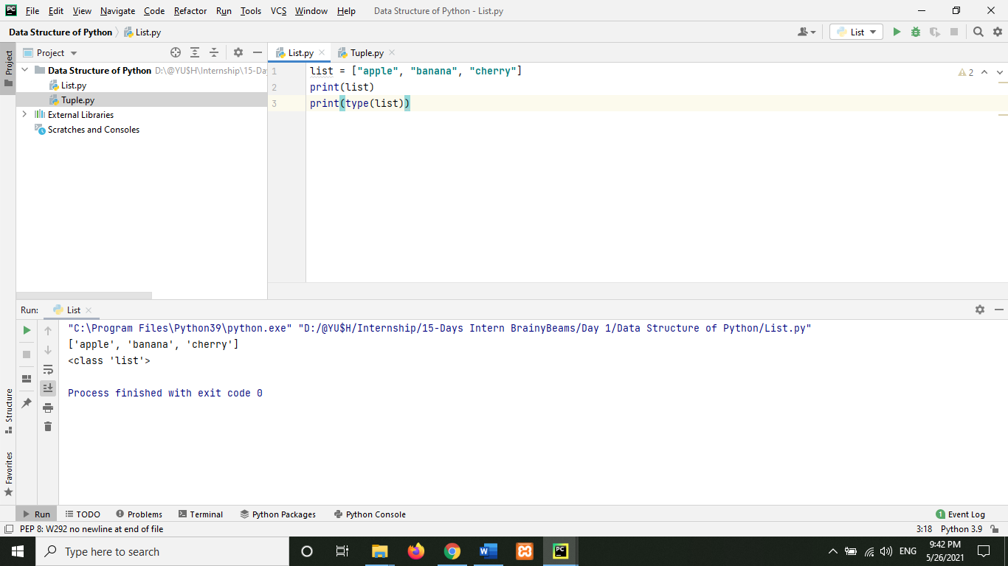

1. **Tuple**

**tuple = ("apple", "banana", "cherry")  
print(tuple)  
print(type(tuple))**

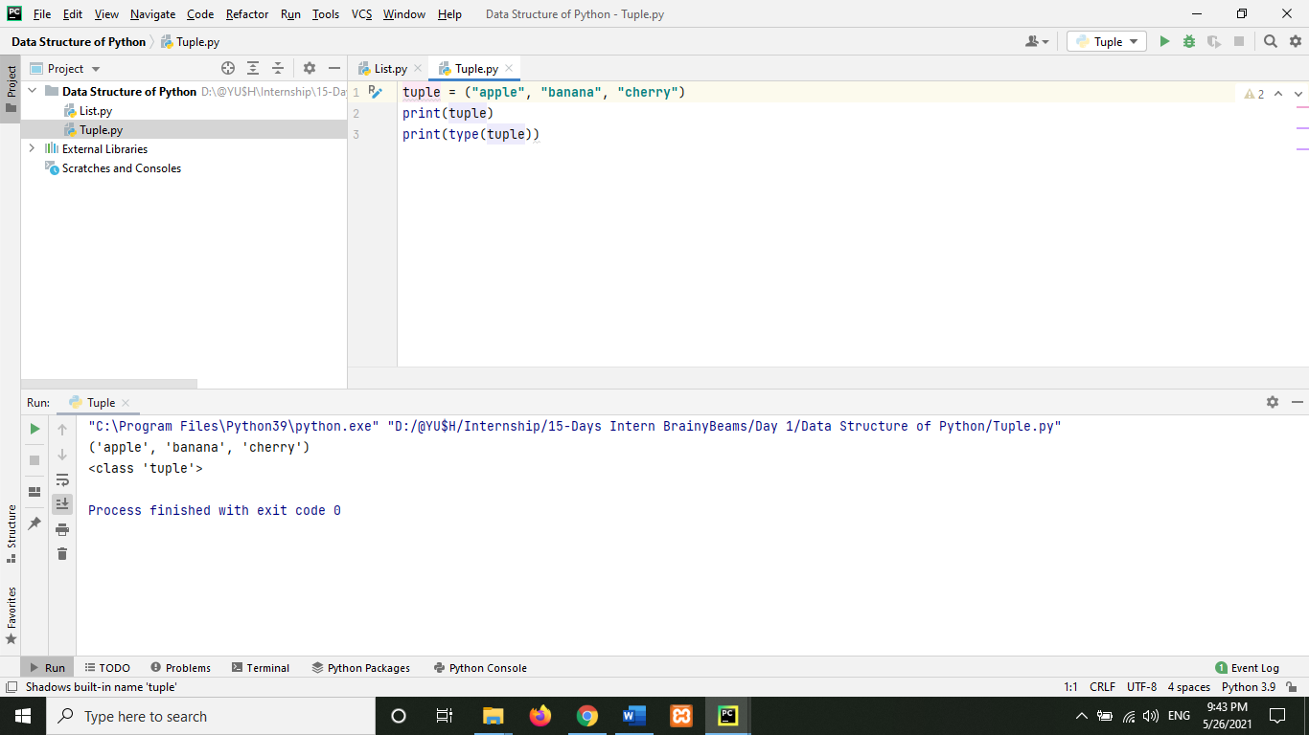

1. **Set**

**set = {"apple", "banana", "cherry"}  
print(set)  
print(type(set))**

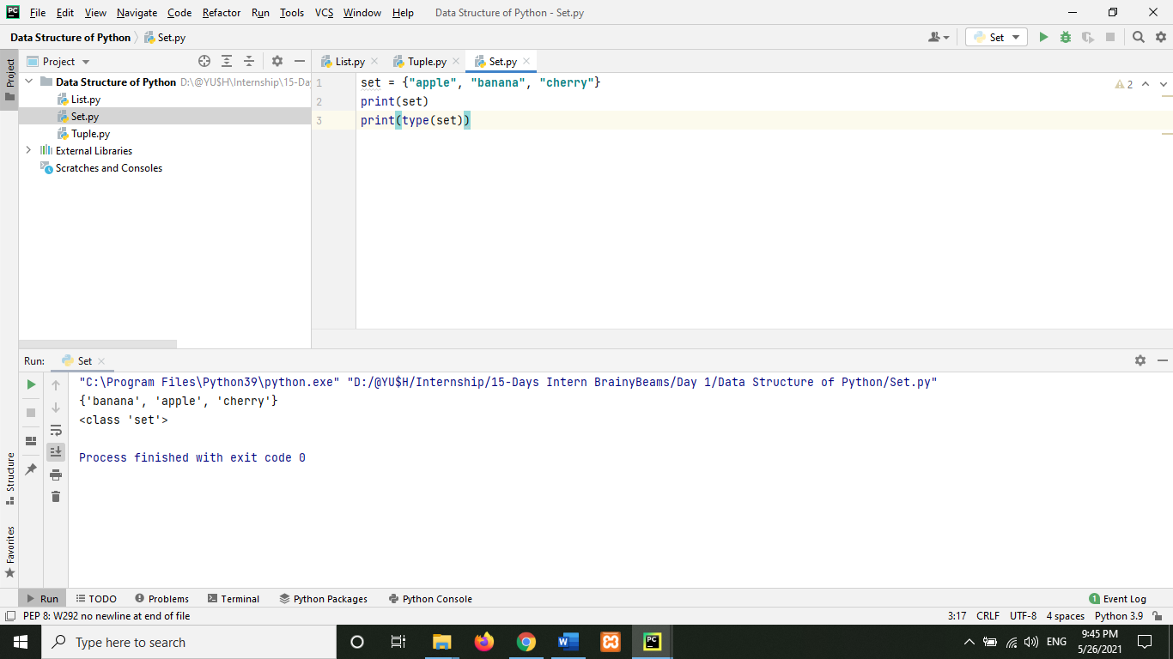

1. **Dictionary**

**dict = {  
 "name": "Ayush Prajapati",  
 "Age": 21,  
 "Sem": 7,  
 "college": "ASOIT"  
}  
print(dict)  
print(type(dict))**

